Bransby Horses Accessibility Statement 2026

Introduction
Bransby Horses is a registered equine welfare charity (Charity Number 1075601) and Visit England Accredited visitor attraction situated in the small hamlet of Bransby, 8 miles outside the historic city of Lincoln.
Access to the site is situated on flat land with small country lanes.

We are a working farm and visitors are able to wander around the yards and walkways at their leisure, seeing the valuable work we do with the horses, ponies, donkeys and mules in our care. Due to operational needs, there may be restricted access to yards and walkways at some times.

We have over 200 animals on site, with information boards throughout the yards. We have excellent visitor facilities, starting with your welcome at our Visitor Centre, which opened in 2013. Please allow between 1.5 - 2 hours to see all of our site. Entry to the site and parking are both free, however we do ask for a donation to contribute to our ongoing welfare work.

We have a Gift Shop, Café and outside Courtyard area that have good wheelchair access, adequate seating and which are level throughout. We have wheelchairs available for loan free of charge while on site and which can be booked in advance.

All measurements in this Access Statement are approximate. For further information or to confirm any details, please contact us on the numbers provided at the end of this document.
We look forward to welcoming you. If you have any queries or require any assistance please phone 01427 788464 or email shop@bransbyhorses.co.uk.

Pre-Arrival
- For full details and maps of how to reach us please see the Visit Us section of our website .
- The nearest railway station is Saxilby, which is 3 miles by car.
- There are no direct buses to Bransby village, however Call Connect buses can be booked in advance.
www.lincsbus.info/callconnect Transport Helpline 0345 456 4474
Traveline 0871 200 22 33
- Our website is www.bransbyhorses.co.uk/visit-us which gives a good insight into our work and will help you to plan your day with us.

Car Parking and Arrival
- There is ample car parking on site with 4 designated spaces providing wide access (approximately 1200mm wide) for disabled visitors, 3 designated parent and child parking spaces and 3 mini bus spaces.
- There is a 1200mm safe zone to the rear of the designated parking spaces for boot access and cars with rear hoists.
- The access to these disabled parking spaces has preferred route access in order to avoid travel directly behind parked cars.
- The distance from the first space to the Visitor Centre entrance is approximately 20 metres.
- 37 x Standard car parking spaces which are 2400mm x 4800mm.
- The main on-site car park has a tarmac finish road with paved parking spaces, leading in to the Visitor Centre.
- There is also provision for 117 vehicles of over flow car parking on stoned surface.
- Car parking is free of charge.
- Access in to the Visitor Centre is up a dropped curb.
- Flood lighting is used throughout the car park for high visibility.
- There is a drop off point at the Visitor Centre entrance with a dropped curb.

Image: Accessible parking
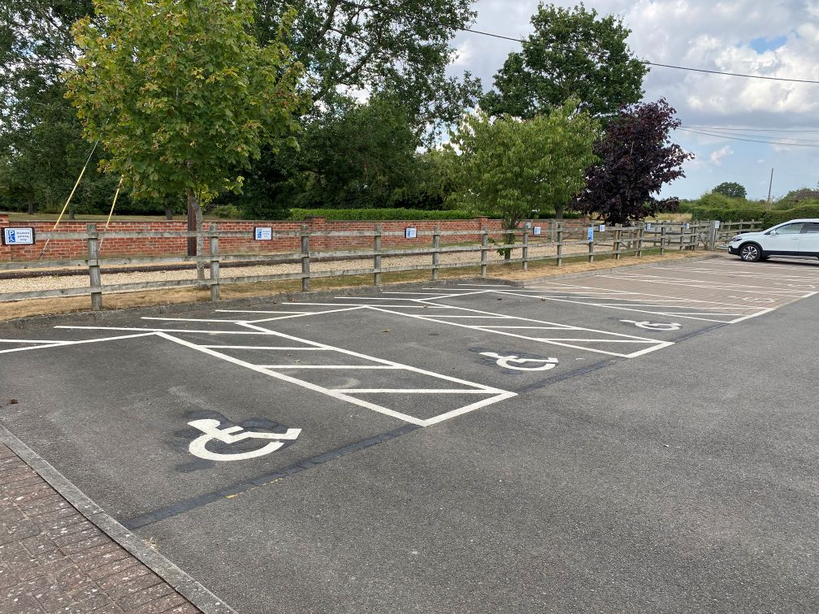

Image: Access to the main Visitor Centre

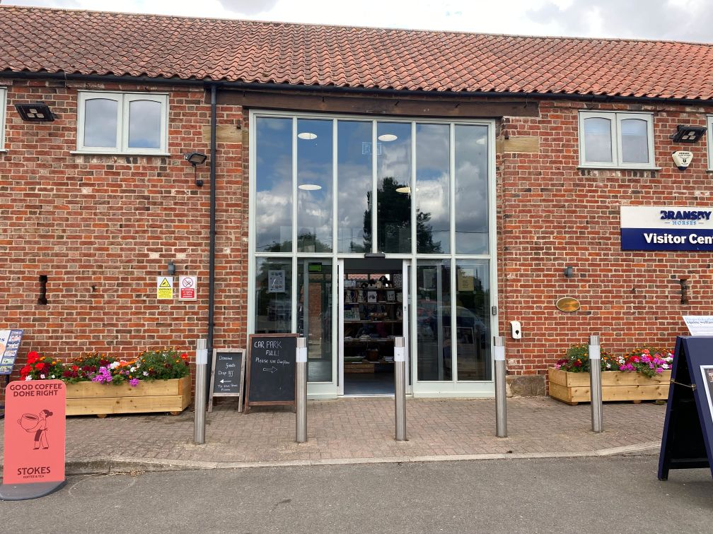

Visitor Centre
The main doors into the Visitor Centre are on sensors and remain open until the doorway is cleared.
- The main doors to the Visitor Centre open to allow 89cm clear access space.
- The flooring is laid with stone tiling throughout, with a small short-pile carpeted area at the main entrance as a safety feature during wet weather.
- There are no steps into the building.
- The main visitor reception is situated on the ground floor, just 5 meters from the main entrance.
- The flooring throughout is level with no steps or ramps.
- The area is well lit with ceiling spotlights throughout.
- The main counter at the reception stands at 94cm, reducing to 76cm at the front to allow easy access for disabled visitors or children.
- A wheelchair is available for loan throughout your visit if required.
- There is a double door fire escape by the Visitor Centre reception desk, which opens to allow a clear 97cm access.
- There is a second double door fire escape by the lift, which opens in an outward direction to allow a clear 97cm access.
- The Visitor Centre has a 5 person, 410kg capacity lift which allows disabled access to the offices and business meeting room on the first floor.
- The lift door allows a clear 91cm access and the control buttons and alarms are 89 cm from ground level. The emergency phone is approximately 63 cm from ground level and connects to the Visitor Centre reception. Use of the lift is by permission only and a key must be obtained from the reception desk.
- If the first-floor meeting room is in use during an evacuation, there is an 'Evac slide’ located at the top of the stairs, by the lift. There are members of the Visitor Centre team trained in its use.
Image: The gift shop counter

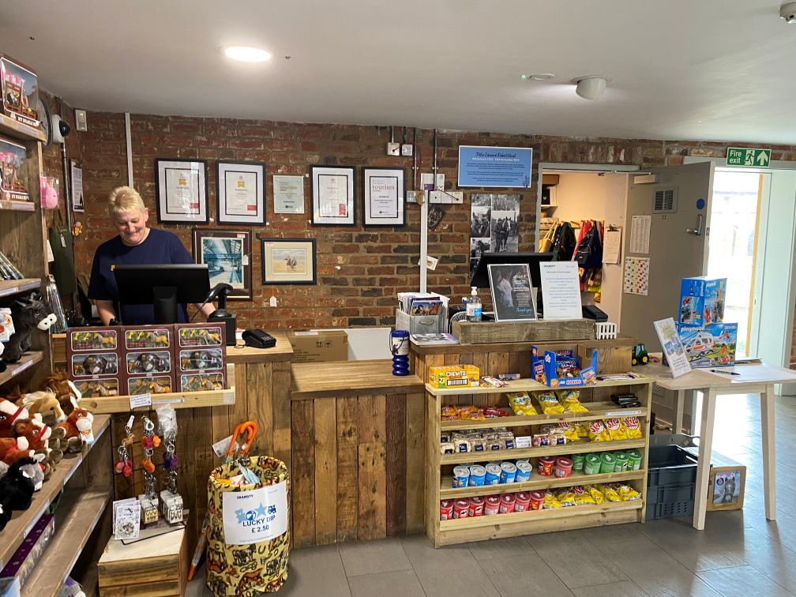

Images: Lift and Wheelchairs
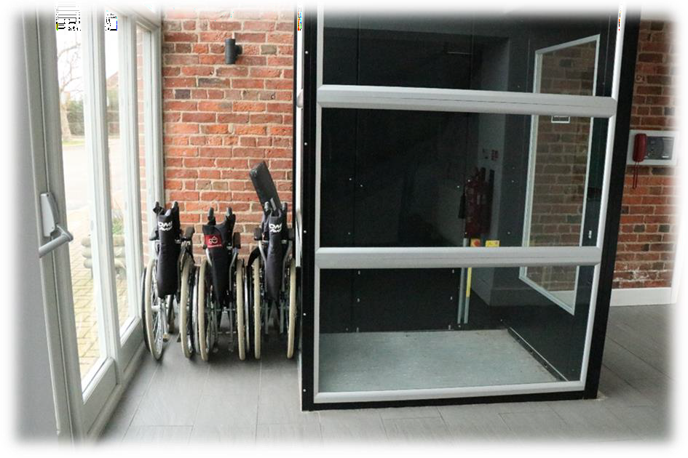

Attractions
- The font size is large and easily read and accompanied by a variety of graphics.
- The language used throughout site is English (UK).
- Our site does not currently have any Braille translations.
- All of our internal displays are highlighted by plain ceiling spot lights.
- The café overflow area is accessed via a ramp and through a door which can be pushed with one hand and stays open until manually closed.
- The main access doors to the café overflow area open to allow 112 cm clear access.
- The floor surface in the is stone tiling.
- There are benches placed around the walkways to allow rest breaks to all visitors.
- There is a video on display in the Feedroom Café featuring our welfare work.
- We offer a variety of tours, meet and greets and educational demonstrations and presentations suitable for all.
- The door way to the Donated Rug and Tack Shop measures 106 cm clear access up a ramp, with a safety barrier.

Images: Access to the Donated Goods Shop

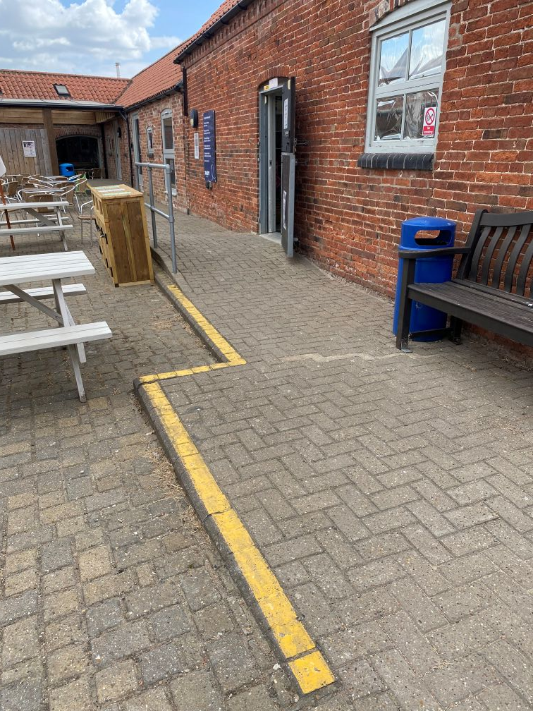
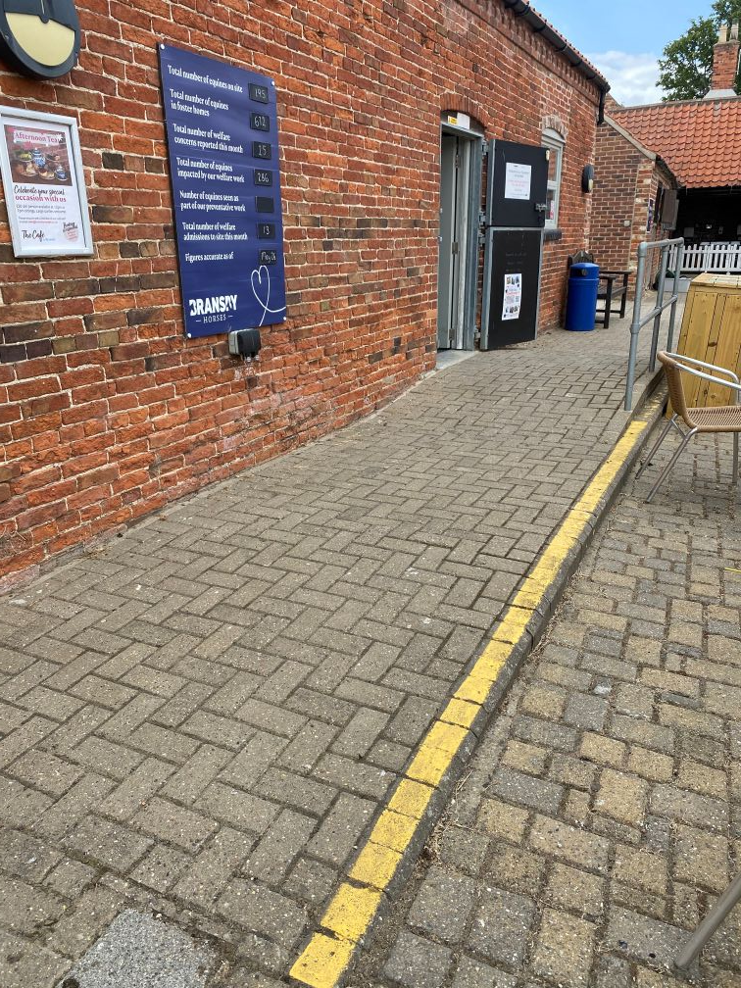

Public Toilets
There are two disabled toilets located on site. One to the right-hand side of the Visitor Centre, through the Gift shop, the second at the visitor toilet block, between Jimmy’s Jolly and Lizzie’s Lane, marked on the visitor map.
- There are two accessible toilets which are unisex. The door can be opened with one hand by the handle which is approximately 102 cm from ground level.
- The toilet has a standard flush capability.
- The disabled toilets in both areas have a door width of approximately 99 cm.
- The toilet stands at 51 cm sitting height and has a lower back support mounted.
- The sink stands at 71 cm height, with left and right levered taps.
- The soap and tissue dispensers stand at 76 cm height.
- The hand dryer is motion activated and stands at 94 cm height.
- There is space for a wheelchair to maneuver left of the toilet.
- There are fixed support rails to the left of the toilet, one vertical and one horizontal.
- There is a pull-down arm rest mounted on the wall to the right of the toilet.
- There is a fixed support rail mounted on the back of the toilet door.
- There is a red cord emergency assistance call system in place, which can be heard through the visitor Centre.
- The lighting is controlled by a motion sensor.
- The floor is non-slip laminate.

Image: Visitor Centre unisex accessible toilet in the visitor centre
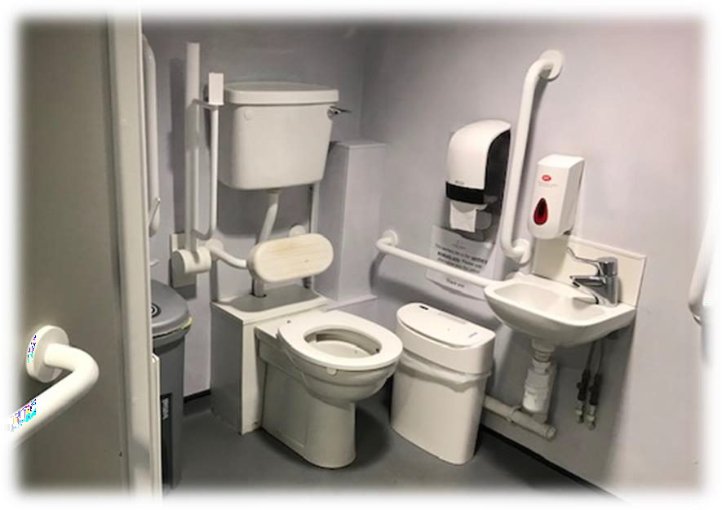

Catering
- The Café is located to the left of the Visitor Centre, through the Gift shop on the ground floor.
- The floor is a stone tile and there are no steps or ramps to access.
- The layout is open plan with furniture not fixed so that it can be moved round.
- The tables stand at approximately 79 cm from the ground and the chairs stand at 46 cm from the ground. The chairs do not have arm rests.
- The lighting is predominantly bulb with up/down lights mounted on the walls.
- The Café offers vegan and gluten free options.
- Service in the Café is table service.
- The catering staff are happy to discuss ingredients, intolerances and menu options with our visitors.
- The Café counter stands at approximately 84 cm high.
- There are two unisex toilets located by the Café, however these are not set up for wheel chair or push chair users.
- There is a fire escape in the Café which is located by the counter. The door offers approximately 89 cm clear access and opens in an outward direction.

Shops
- The Gift Shop is located in the centre of the Visitor Centre.
- The main doors in to the Visitor Centre are on sensors and remain open until the doorway is cleared.
- The main doors to the Visitor Centre open to allow 89 cm clear access space.
- The flooring is laid to concrete tiling throughout, with a small short- pile carpeted area at the main entrance as a safety feature for during wet weather.
- There are no steps into the building.
- The Gift shop is open plan with large spaces for maneuverability.
- The counter stands at approximately 94 cm, reducing down to 76 cm at the front for easy access.
- The goods displays are on fixed shelving with the lowest shelf being at 30 cm from ground level up to 182 from ground level for the highest shelves.
- Please ask staff for assistance, they are always willing to help.
- There is a fire door located immediately adjacent to the main Visitor Centre doors. There is a step down out of this fire escape with metal ramp in place, though assistance is always available.

Outdoor Facilities
The charity has a wooden play park covered with woodchip. Unfortunately, this area is not suitable for wheelchair users.
- There is a picnic area and a wooded memorial garden which are both situated on even well-draining grass land. In extremely wet weather these areas may not be accessible.
- In the main picnic areas to the rear of the Visitor Centre, there are various wheelchair accessible picnic benches for your convenience.
- The main walkways are predominantly chalk/rubble and are accessible by pushchairs and wheelchairs in most weathers. They are relatively even with minimal inclines.
- The main walkways are approximately 305 cm wide.
- There are seating areas around the walkways.
- There are no paths along the main road running through Bransby village. We recommend that visitors do not walk down the road. Those that do, do so at their own risk. The walkways onsite provide access to all some areas of the farm – this may vary depending upon operational requirements.
- If assistance is required while on site, members of staff have radios to call for help or visitors can call the shop on 01427 782860. Please bear with us as we may not be able to answer immediately.
- There are gates around site to ensure the protection of our animals and to protect visitors in case of farm machinery moving around site. These gates swing both ways and are secured by a closure of which the highest is approximately 142 cm from the ground.

Image: Accessible picnic tables

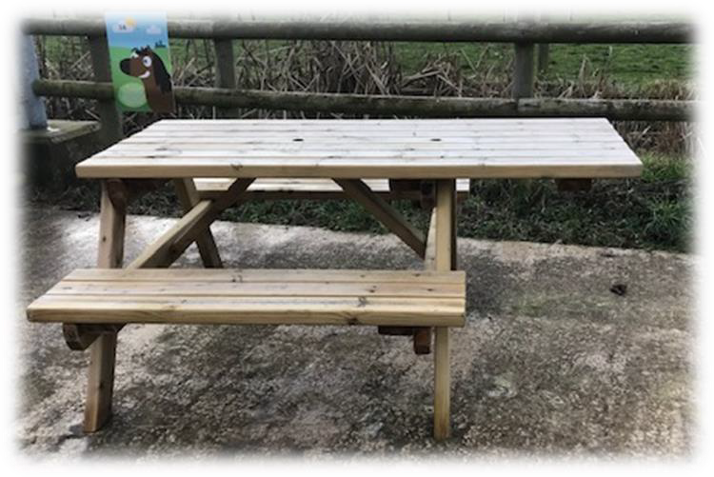

Image: Access to the main walkways from the Visitor Centre

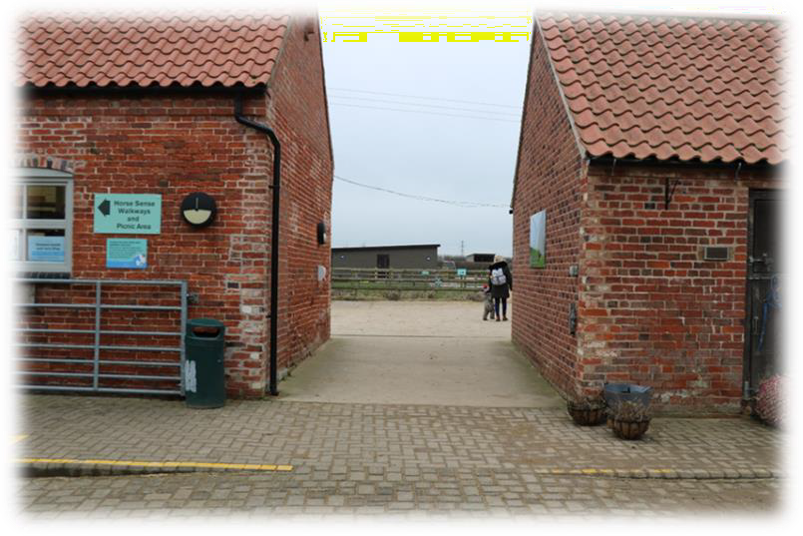

Additional Information
- Dogs are welcomed on site, though we do ask that only guide and assistance dogs are taken into the main Café area. All dogs are welcome in our outside seating area and the additional inside area adjacent to the main Cafe. Dogs are to be kept on leads at all times and bins are provided to clear up after them.
- Dog stops with water bowls are located in the Café outside seating area and at the Donated Rug and Tack shop.
- Hand wash areas are located at the back of the Visitor Centre courtyard, at the bottom of Alfred's Amble walkway and on the main yard opposite the information point.
- Hand sanitizers are located in the Visitor Centre Courtyard, behind the Welcome Barn, on the main yard near the toilets, on the Peter Hunt yard at the start of Philly's Footpath, on Johnsons Jaunt and at Walkland's Farm.
- The Emergency evacuation arrangements will be led by the duty manager and staff present at the time.
- All visitors are required to make their way to an assembly point in the event there is an incident, staff will advise visitors of the need to do this and where to go as required. When inside the Visitor Centre, the assembly point is in the car park to the front of the building.
- Please be aware that Bransby Horses is a working farm and as such there will be machinery and vehicles moving around site, as well as horses being moved. Please be vigilant at all times.

Image: Hand wash area located behind the Visitor Centre building
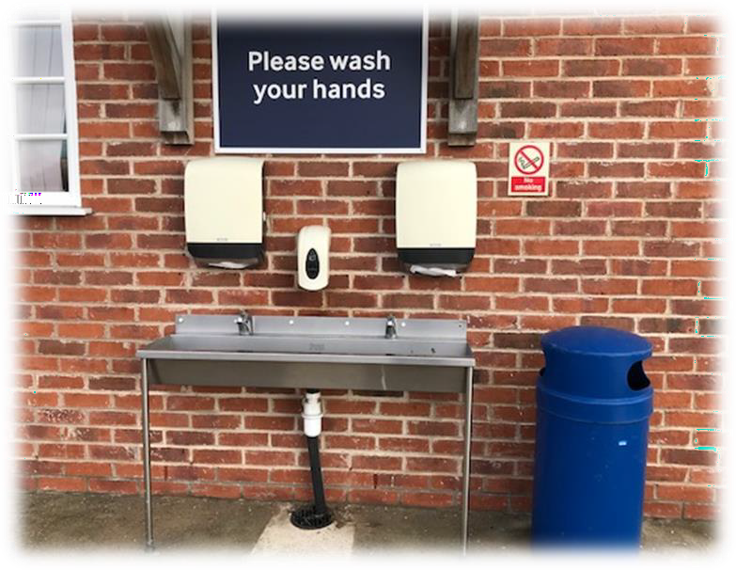

Contact Information

Address (Inc postcode): | Bransby Horses Bransby Lincolnshire LN1 2PH
Telephone: | 01427 788464
Email: | shop@bransbyhorses.co.uk
Website: | www.bransbyhorses.co.uk
Opening Hours | Open Wednesday – Sunday 10am-4pm.  Closed Christmas Day, Boxing Day and New Year’s Day.
Local Public Transport: | Call Connect 0845 2343344

