****************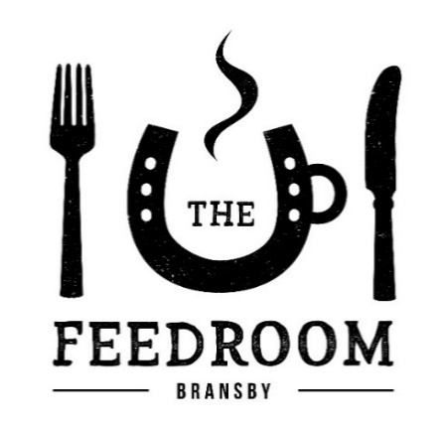

**LINCOLNSHIRE SAUSAGE & MASH** …………………………… £**6.95**

Served with red wine and onion gravy and peas

**VEGGIE SAUSAGE & MASH (v)**……………………………………..**£6.95**

Served with red wine & onion gravy and peas.

**VEGETARIAN COUNTRY PIE(V)**………………………………….….**£7.95**

Served with mashed potato and peas.

**STEAK AND ALE PIE**……………………………………………..……….**£7.95**

Served with mashed potato and peas.

**COTTAGE PIE…**……………………………………………………………..**£6.95**

Served with fries and peas.

**RUSTIC VEGETABLE SOUP..………………………………………...£3.95**

Roasted root vegetables with a touch of garlic.

(Vegan and Gluten Free)

Lunchtime Menu served 12noon-3:00pm Monday-Sunday

**WHOLETAIL SCAMPI**…………………………………………..………..**£6.95**Served with chips, peas & tartare sauce.

**WILTSHIRE HAM, EGG & CHIPS** ……………………..…………….**£6.95**Served with free range eggs & peas.

**THE BEEF BURGER**……………………………………………………..…**£6.95**Served with fries & homemade coleslaw.

**THE CHICKEN BURGER**………………………………………………….**£6.95**

Served with fries & homemade coleslaw.

**THE VEGAN BURGER (v)**……………………………………………….**£6.95**

Served with fries & onion relish.

**BLT WRAP ……………………**…………………………………………….**£5.95**

Served with fries & homemade coleslaw.

**SOUTHERN FRIED CHICKEN WRAP .**…………………………….**£6.95**

Served with fries and homemade coleslaw

*Served with Side Salad*

**JACKET & CHEESE (v)**……………..……………………………………..**£4.95**

**JACKET & BEANS (v)**……………………………………………………..**£4.95**

**JACKET & TUNA MAYO**…………………………………………………**£5.95**

**JACKET & PRAWN MAYO**……………………………………………..**£6.95**

**JACKET & COLESLAW (v)**……………………………………………….**£4.95**

**EXTRA FILLINGS**

Tuna Mayo **£2.95** – Beans (v) **£1.00** – Bacon **£2 (2 Slices)** -   
Cheese(v) **£1.50** – Coleslaw (v) **£1.50** - Prawn Mayo **£3.50**

Served with Side Salad & Coleslaw

**BACON, BRIE & CRANBERRY**………………………………………..**£5.95**  
**BRIE & CRANBERRY (v)**…………………………………………………**£4.95**  
**TUNA CHEESE MELT**……………………………………………………..**£5.95**

**CHEESE & ONION (v)**…………………………………………………….**£4.95**

**HAM & CHEESE**…………………………………………………………….**£5.95**

***Note:*** *Please be aware that our vegetarian options are cooked using the same panini press used for meat and fish products.*

**CHEESE (v)**…………………………………………………………………….**£5.95**

**PRAWN**…………………………………………………………………………**£6.95**

**HAM**……………………………………………………………………………..**£6.95**

**TUNA**…………………………………………………………………………….**£6.95**

Breakfast Menu served 9am-11:45am

**THE FULL ENGLISH**………………………………………………………..**£6.95**Lincolnshire sausage, bacon, egg, grilled tomato,   
toast, mushroom, beans and hash browns.

**THE VEGETARIAN (v)**…………………………………………………….**£6.95** Quorn sausages, egg, mushroom, toast, grilled tomato, Beans and hash browns.

**THE BREAKFAST WRAP**…………………………………………………**£3.95**

Lincolnshire sausage, bacon, hash browns and tomatoes.

**PANCAKES (v)**……………………………………………………………. **£3.50**

Served with maple syrup’ add crispy bacon for .. **£1.00 extra**

**WAFFLES (v)**……………………………………………………………….. **£3.50**

Served with maple syrup’ add crispy bacon for **£1.00 extra**

**SCRAMBLED EGGS (v)**…………………………………………………**…£2.95**

**BACON BAP**………………………………………………………………….**.£2.95**

**LINCOLNSHIRE SAUSAGE BAP**………………………………….……**£2.95**

**VEGGIE SAUSAGE BAP (v)** …………………….……….…………. **£2.95**

**INDIVIDUAL ITEMS**Bacon **£1** - Beans **£1** - Mushroom **75p** - Egg **£1** - Lincolnshire Sausage **£1** - Grilled Tomato **75p** - Hash Brown **75p** - Toast **£1.50**

**SEASONAL VEGETABLES . £2.95 SIDE SALAD** ………….…….**£2.95**

**FRIES (v)**…………………….**£2.50 CHEESY CHIPS (v)**…………**£3.50**

Served on White or Malted Bread and a Side Salad

**CLUB SANDWICH**………..………………………………………………..**£4.95**

**CHEESE (v)**…………………………………………………………………….**£3.95**  
**HAM**……………………………………………………………………………..**£3.95**  
**TUNA**…………………………………………………………………………….**£4.95  
PRAWN MAYO**……………………………………………………………..**£4.95  
FISH FINGER**………………………………………………………………….**£3.95**

***TOAST ME FOR 50P EXTRA!***

(v) – Suitable for Vegetarians

If you have any dietary requirements please inform a member of Café staff so we can assist you with your food choices. If you have a specific food allergy please speak with a member of staff for information about ingredients. If in doubt please ask to speak with the Catering Manager, Team Leader or Cook.