********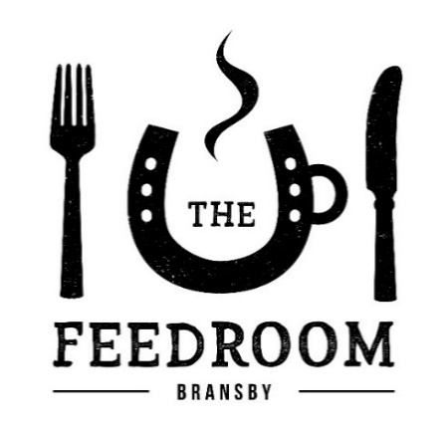

Lunchtime Menu served 12noon-2.30pm Wednesday-Sunday

**WILTSHIRE HAM, EGG & CHIPS** ……………………..…………….**£7.95**

Served with free range eggs

**THE BEEF BURGER**……………………………………………………..…**£7.95**Served with fries & homemade coleslaw.

**THE CHICKEN BURGER**………………………………………………….**£7.95**

Served with fries & homemade coleslaw.

**THE VEGAN BURGER (v)**……………………………………………….**£7.95**

Served with fries & onion relish.

**BLT WRAP ……………………**…………………………………………….**£7.95**

Served with fries & homemade coleslaw.

**SOUTHERN FRIED CHICKEN WRAP .**…………………………….**£7.95**

Served with fries and homemade coleslaw

Breakfast Menu served 10am-11:45am

**THE FULL ENGLISH**………………………………………………………..**£7.95**Lincolnshire sausage, bacon, egg, grilled tomato,   
toast, mushroom, beans and hash browns.

**THE VEGETARIAN (v)**…………………………………………………….**£7.95** Quorn sausages, egg, mushroom, toast, grilled tomato, beans and hash browns. (Vegan available ask your Chef)

**SCRAMBLED EGGS (v)**…………………………………………………**…£3.50**

**BACON BAP**………………………………………………………………….**.£3.25**

**LINCOLNSHIRE SAUSAGE BAP**………………………………….……**£3.25**

**VEGGIE SAUSAGE BAP (v)** …………………….……….…………. **£3.25**

**Potato Salad ………………………………. £ 4.00**

**Garden Side Salad………………….……. £ 3.50**

**Homemade Coleslaw** ………………….. **£2.50**

**Fries (v)**………………………………..….…. **£ 2.50**

**Cheesy Chips (v)**……………………….… **£ 3.50**

**Crusty Bread ……………………………… £ 2.00**

**Cheese (v)**…………………………………………………………………….**£6.95**

**Prawn** ………………………………………………………………..……**£7.95**

**Wiltshire HAM** …………………………………………………………..**£7.95**

**Tuna Mayo** ………………………………………………………………….**£7.95**

**Ploughman’ Salad ………………………………………………………£7.95**

**Beetroot & Goats Cheese …………………………………………..£7.95**

**Goats Cheese removed for a vegan option**

**Salad Contains: Mixed leaf, Onions, Cucumber, Tomato and Five Bean salad, no dressing.**

If you have any dietary requirements please inform a member of Café staff so we can assist you with your food choices. If you have a specific food allergy please inform a member of staff and ask for information about ingredients. If in doubt please ask to speak with the Catering Manager, Team Leader or Cook.

*Served with Salad Garnish*

**JACKET & CHEESE (v)**……………..……………………………………..**£5.95**

**JACKET & BEANS (v)**……………………………………………………..**£5.95**

**JACKET & TUNA MAYO**…………………………………………………**£6.95**

**JACKET & PRAWN MAYO**……………………………………………..**£7.95**

**JACKET & COLESLAW (v)**……………………………………………….**£5.95**

Served on White or Malted Bread with a Salad garnish

**C****heese** ………………………………………………………………….**£4.95**

**Ham & Wholegrain**………………………………………………….…**£4.95**

**Tuna** **Mayo**………………………………………………………………...**£4.95**

**Prawn Mayo**……………………………………………………………...**£5.95**

**Coronation Chicken ….**………………………………………………**£5.95**

**Egg & Cress ……………………………………………………………..£4.95**

***!***